Programming Fundamentals Lab

Lab Assignment 09

Course Code: CL1002

Syed Muhammad Shuja Ur Rahman

Roll No. 22K-4456

Ms. Ayesha Ali

**QUESTION#1**

As a programmer, you are required to create a program that takes the first and last name from a user. The program

then combines both the inputs taken and prints the string backwards.

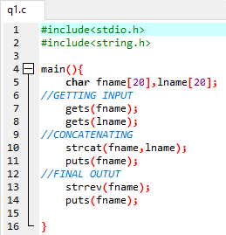

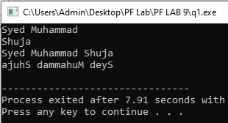

**QUESTION#2**

Each student is required to find out the maximum frequency of characters occurring in their name and the courses offered in Fall 2021. To find it, the student enters their name, courses offered and the program finds the maximum occurrences of a character in the name and course. Course names should be used like Programming Fundamentals, Applied Physics, Pakistan Studies and so on.

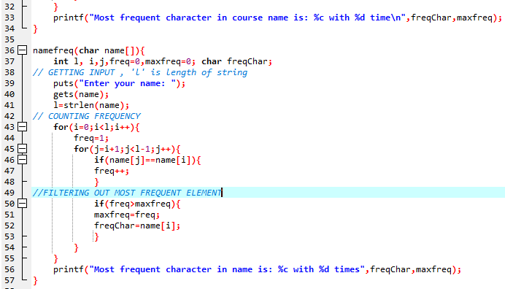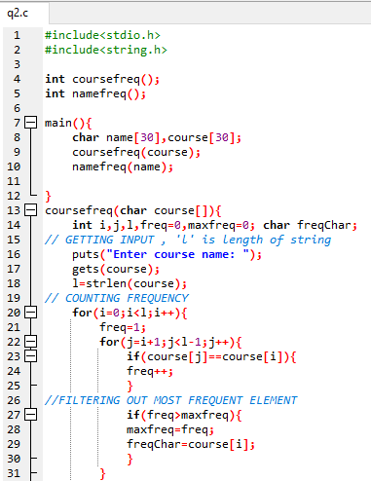

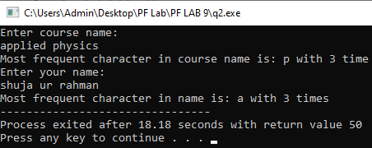

**QUESTION#3**

Students are grouped in two to complete a lab task. Each student is required to enter a string of their own choice as an input to the program. The program will then display as a result whether both the strings are equal. If the strings are not equal, the program will display which of the string is greater.

Test cases:

1. Enter two strings that are same.

2. Enter two different strings.

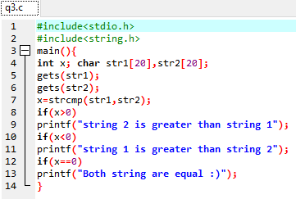

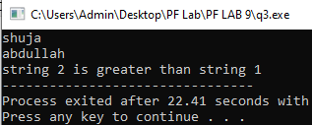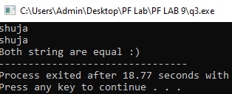

**QUESTION # 4**

Salesflow is one of leading software house they are starting their recruitment process for three different following positions:

1. Associate Developer

2. Assistant Developer

3. Trainee Engineer

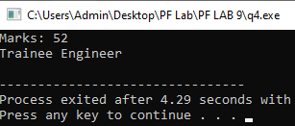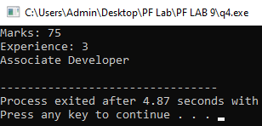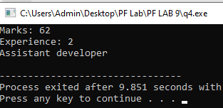There is defined criteria for recruitment process, if candidate clear the test with 50 marks then he will be select for the post of trainee engineer, experience is not the requirement in it. if candidate secured 60 marks with one or more than one year of experience and 70 marks with 2 year or more than two years of experience, then he/she will be select as assistant and associate developer respectively. Write a function that will take a test marks from user and ask for experience (if its entered marks x &gt;=60). After that, function will show the assigned position.

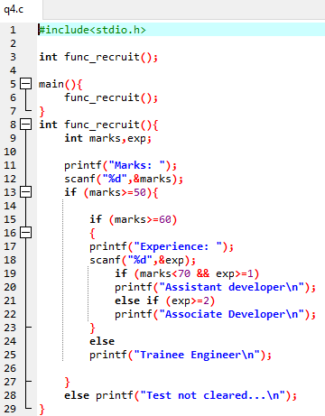

**QUESTION # 5**

Write a function that prints all the unique values from a array and the number of times each value occurs. Below is an output sample. The main function takes a size of array as input and generate a random integer array with name “array1”. Random number limit must be between 0 and 10. The ‘main’ function call a function with the named as “CountFrequency ()”. that will find the occurrence of each value in array.

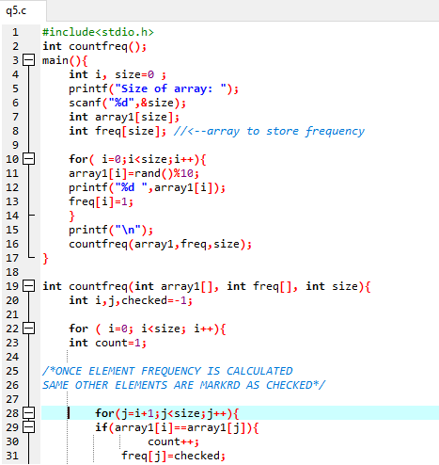

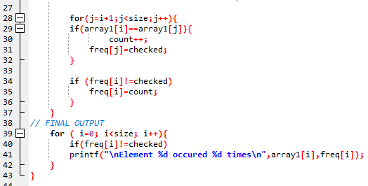

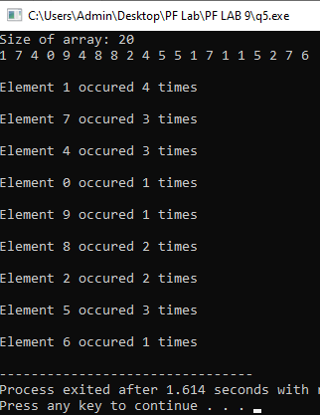

**QUESTION # 6**

Write the program that calculate the volume, V = a2 ∗ 1 /3 ℎ. Create a two separate function

1. One function with the name of “getData (int h, int a)”, that will take two input from user for the variable of “h” and “a”.

2. Second function “volumeCalu ()” will calculate the volume and function must be called by first function “getData ()”. Only first function call from the main function.

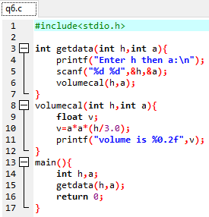

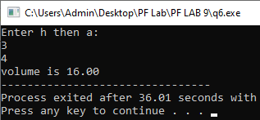

**QUESTION # 7**

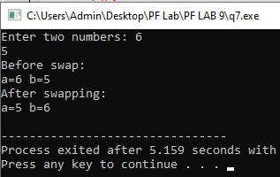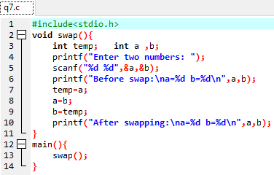Write a program in C to swap two numbers using function.

**QUESTION # 8**

Write a program in C to get the largest element of an array using the function.

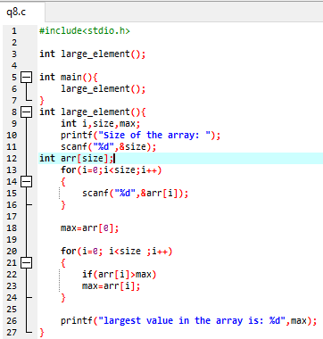

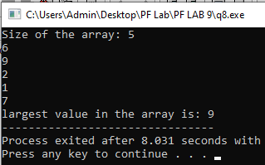

**QUESTION # 9**

Write a C programming to find out maximum and minimum of some values using function which will return an array.

